Name:Nouman Ghazi
Section :3A
Roll no :AI-026
Submitted to : Sir Rasikh Ali sahab

AI Lab Task 9

Topic :
Data Loading AND • Data Exploration
Data set :
Netfix titles
Link :
Disease Prediction Using Machine Learning
Code:
import pandas as pd

Dataset = pd.read_csv("Training.csv")
print(Dataset.head())
print(Dataset.tail())
print("Rows:", Dataset.shape[0])
print("Columns:", Dataset.shape[1])
print(Dataset.isnull().sum())
Dataset = Dataset.fillna(Dataset.mode().iloc[0])
print(Dataset.dtypes)

Screen shots of outputs :
TOP FIVE ROWS :
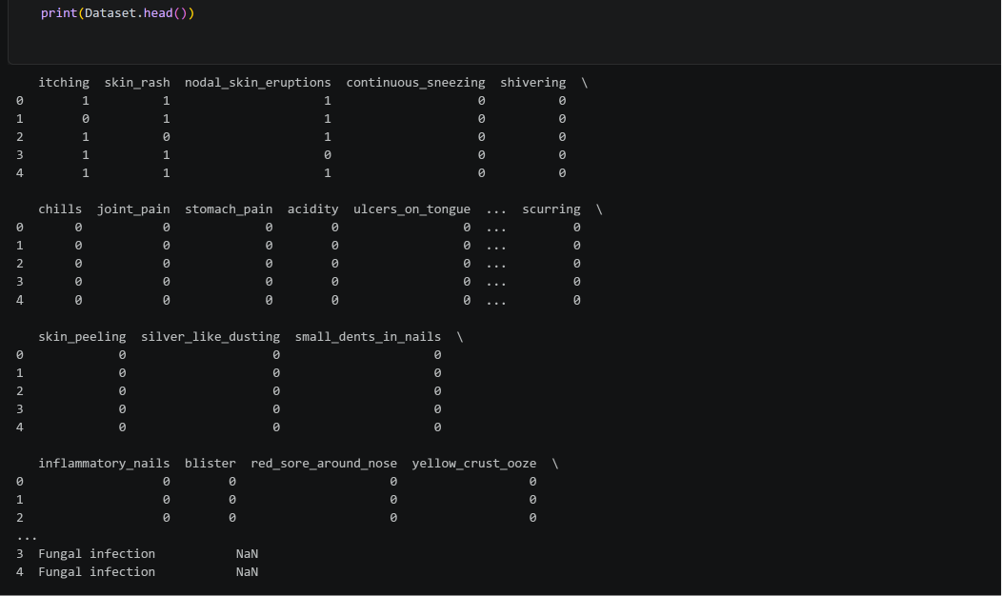
Bottom 5 rows of dataset:
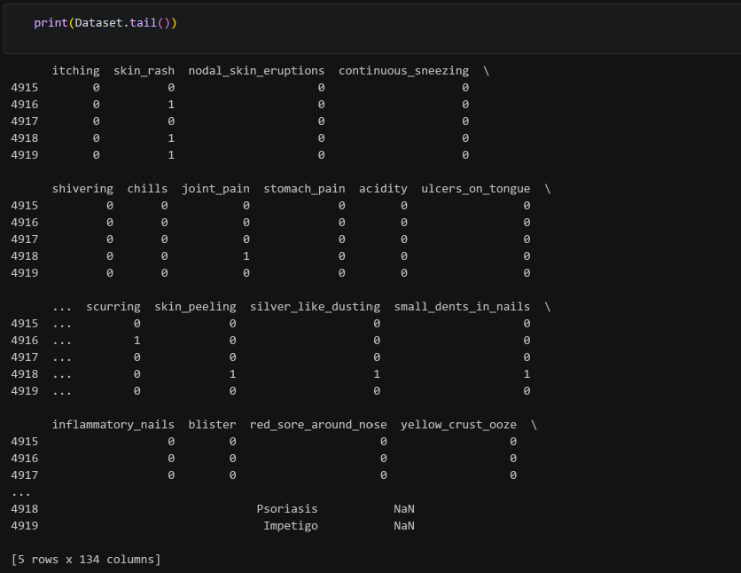
datatype of each column:
